BUDT730: Data Models and Decisions
Professor: Prof. Sujin Kim
“Used-Vehicles Sales Analysis”
Final Project Report
By

Youngseo Chang
Rohith Moravaneni
Kurumi Sato
Ajay Vishwanatha

Ⅰ. Business Problem
- Introduction of the Business Problem
The used vehicle market in the United States is one of the largest in the world. Recent industry estimates put its size at about $1.05 trillion in 2025, with the projected growth to roughly $1.2 trillion by 2030 (Mordor Intelligence, n.d.). This market is large, competitive, and highly sensitive to many factors. Despite its enormous market size, both buyers and sellers still rely on passed-down rules of thumb or generic pricing guides, and it is not always clear which specific attributes drive resale value the most.
We define our business problem as this unclear and non-unified pricing system in the US used vehicle market. Unclear and non-unified value evaluation is not optimal for both the seller and the buyer. Sellers risk underpricing and losing potential profit, or overpricing and holding inventory for too long, which increases cost and asset depreciation. Buyer, on the other hand, may pay more than the fair price, or face confusion and inconsistency when similar cars are listed at varying prices depending on its location.
From this business problem, our team found the need to clarify how used vehicles are priced and evaluated. As a result, our group set the following central business question: “Which factors most strongly influence the resale value of a used vehicle in the United States?”
- Business Questions
Starting from our central question, we derived several more specific questions to guide the analysis. First, we investigate how resale prices differ across U.S. states and which states tend to show the highest resale values overall. Second, we analyze pricing deviations by comparing selling prices to MMR values to see how often, and by how much, vehicles sell above or below benchmark. Third, we examine brand effects, asking which car brands retain their value best and how resilient they are in the used-vehicle market. Together, these questions allow us to identify which features most strongly influence selling prices and ultimately answer our main business problem.
- Utilized Data
To address this problem, our team aims to analyze how different factors influence the resale value of used cars in the United States using the Kaggle "Vehicle Sales and Market Trends" dataset (Vehicle Sales Data, n.d.). This dataset contains approximately 550,000 transactions across the U.S. over an eight month period. For each transaction, the data includes information on vehicle attributes such as year, brand, make, model, trim, condition, mileage, state, and sale date.
- Data Cleaning
Before conducting any analysis, our team cleaned the dataset to ensure accurate and reliable results. Several categorical fields such as make, model, body, color, and transmission contained missing values, inconsistent casing, or placeholder symbols. Such values were standardized to prevent the same vehicle type from being split into multiple artificial categories (e.g., “accord” vs “Accord). Moreover, the sale date field was originally stored in an instructed timestamp format. This was converted to a clean YYYY-MM-DD date variable.
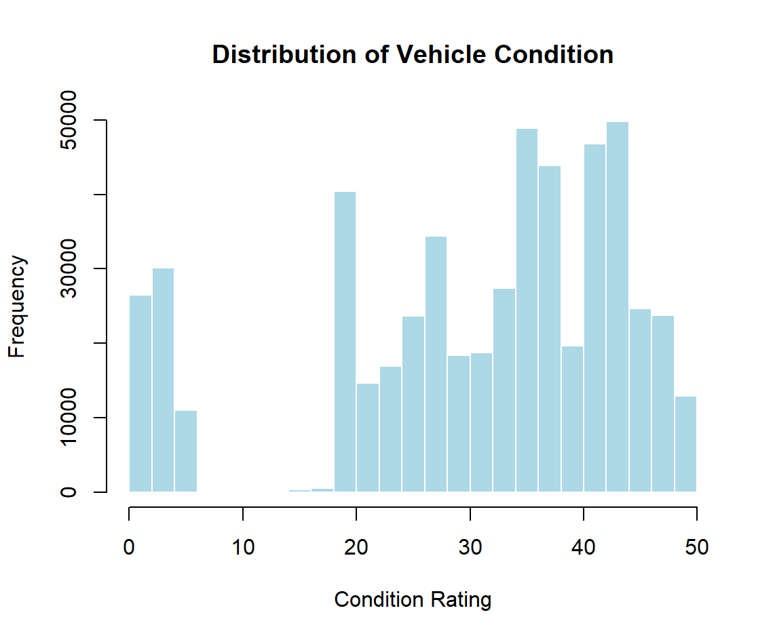
Vehicle condition is one of the most important factors influencing resale value and is recorded on a 0-50 scale. However, the dataset had over 11,000 missing condition scores. The distribution of the existing condition scores was found to be left-skewed, with a long tail of lower quality vehicles. The median was chosen to replace the missing values, as it is less sensitive to outliers than the mean.
Finally, we identified over 8,000 duplicate VINS. These were not data errors, but the repeated sales of the same used vehicles appearing with different sale dates and prices. To avoid double counting, we chose to keep only the first recorded sale of each VIN in our main dataset. A secondary dataset was created to contain the repeated sales to potentially explore how used vehicles depreciated over multiple transactions.

ⅠⅠ. Statistical Analysis
- How do resale values vary across states?
To compare resale prices across states, we cleaned the main dataset, standardized state codes, and kept only valid U.S. states. We then grouped transactions by state and calculated summary statistics for selling price, including the mean, median, standard deviation, and percentile. Sorting states by mean resale price shows which states markets sit at the top of the distribution and which fall toward the bottom.
From this state-level table, we identified the top fifteen states by average resale price and then focused on the top five. In our sample, Tennessee, Pennsylvania, Colorado, Nevada, and Michigan have the highest average resale prices. In simple terms, vehicles sold in these states tend to transact at higher prices than vehicles sold elsewhere in the dataset.
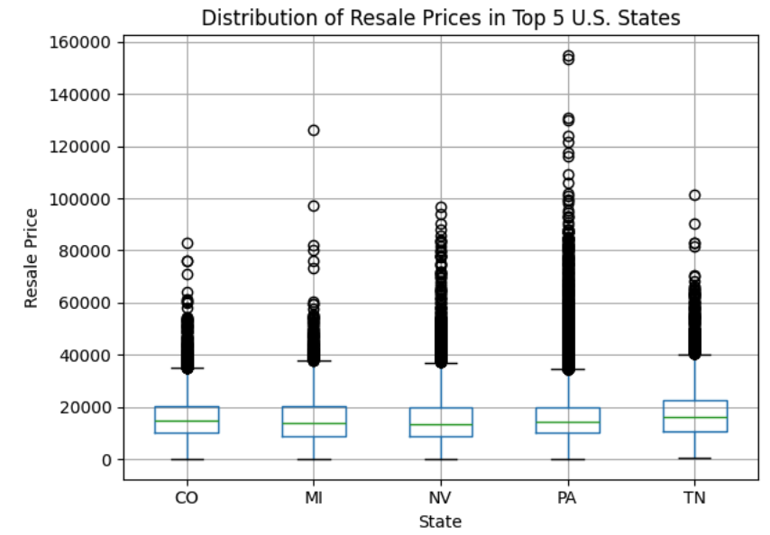
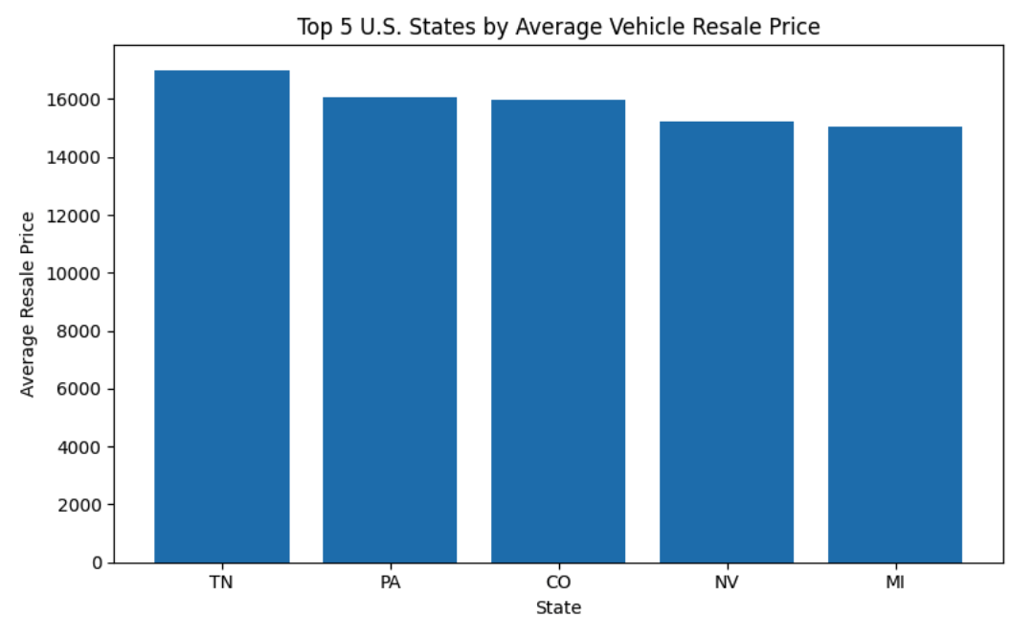
We visualized these patterns using bar charts and box plots. The bar charts highlight the relative gaps in mean resale prices by state, while the box plots for the top states show that higher averages are not just driven by extreme outliers. Medians and interquartile ranges are also elevated, indicating that typical transaction prices are higher in these markets, not just the tails.

However, such comparisons are derived based on the average resale price for each state. A state’s resale value can be high, either because similar cars are valued higher there or because that state simply sells more high-priced vehicles (newer models, luxury brands, high-trim vehicles, etc.). That said, as we have a large number of transactions per state, we expect some of these composition effects and extreme outliers to be partially normalized in the averages and medians.
Even with that limitation, the state-level patterns are strategically important. The fact that average resale prices differ systematically across states means geography should be a factor of consideration when making purchases. On the seller’s side, especially those operating across multiple states and pricing off a single national curve is likely underpricing inventory in higher-value states, while overpricing in lower-value states.
We believe that this analysis can be utilized as a first-layer signal in pricing and logistics. For example, a national dealer could selectively ship vehicles into higher-price states when the expected uplift in resale value exceeds transport and handling costs. Similarly, a marketplace or pricing tool could incorporate state-specific baselines so recommended list prices and trade-in offers reflect local market conditions rather than a generic national average.
- What is the distribution of the difference in the resale value of the car (selling price vs MMR price)?
We explored and analyzed a large dataset of used vehicle sales to determine how different car features can affect the selling price based on various car characteristics such as year, make, model, trim, condition, odometer, body type, transmission, and state of sale. An important aspect of this study is to understand how the MMR (Manheim Market Report) value, a widely used industry benchmark for pricing vehicles, differs from the actual selling price. Understanding the pricing deviations can provide valuable insights for dealers, buyers, and pricing analysts to help identify patterns, estimate fair market value, and make more data-driven decisions in vehicle pricing and negotiation.
To begin the analysis, we created another column called sales difference and performed summary statistics. This helped us understand the distribution of numerical variables such as selling price, MMR, and sales difference.
This provided key insights such as the selling price is $158 less than the MMR and 25% of the cars either sell 800$ below the MMR or 650$ above the MMR. The standard deviation is 1741.06 which is relatively large compared to the mean and shows us there are many outliers.
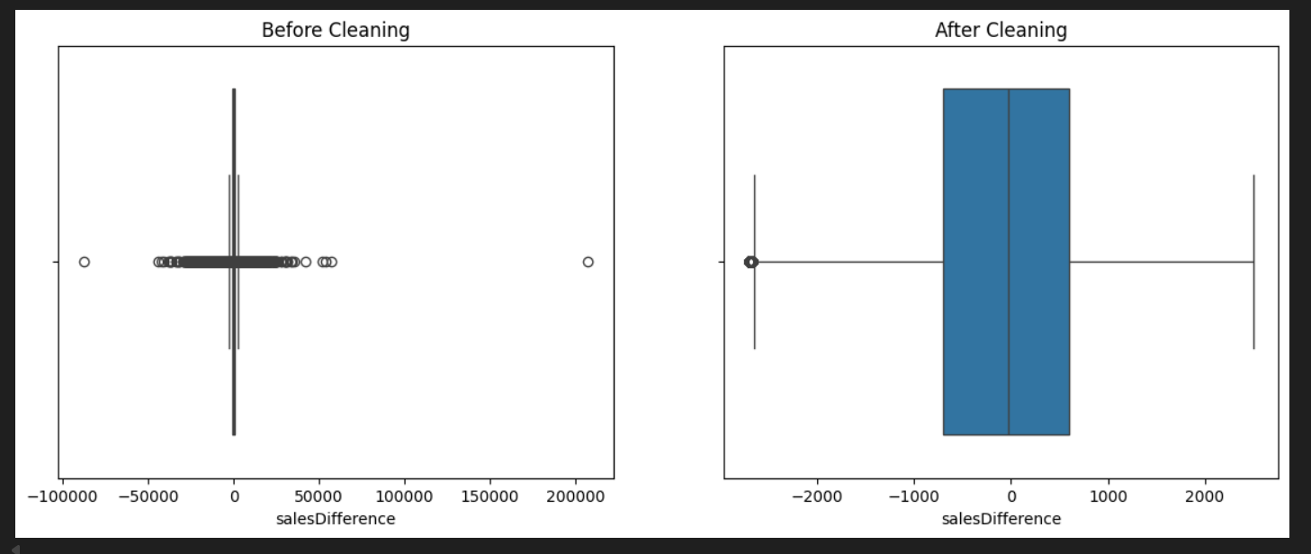
The salesDifference values after cleaning show a much more realistic and stable distribution compared to the raw data. The mean of “- 49.9” indicates that, on average, vehicles sold for prices very close to their MMR value, with only a slight negative deviation. The standard deviation has been reduced to about 1,068, reflecting far less variability than before and confirming that extreme outliers were successfully removed. The interquartile range (- 700 to +600) represents typical market fluctuations, while the new minimum (- 2,700) and maximum (+2,500) values indicate that Winsorization preserved valid but extreme observations without distorting the distribution. The cleaned salesDifference now accurately captures genuine price deviations and is well-suited for regression modeling. Lastly, we created a box and whisker plot that shows us the comparison between the before and after cleaning the data
.
- Which car brand holds value best in the used market?
Mileage is one of the strongest predictors of resale value in the used vehicle market. We wanted to compare how well different brands retain value as mileage increases. To do this, we modeled the relationship between mileage and selling price for each brand. Brands that had less than 50 cars were filtered out to ensure each brand had a relatively large sample size.

Regression Model:
$ln(Selling Price) =β_{0} + β_{1} (Mileage)$
- Dependent variable: log of selling price
- Independent variable: mileage
- $β_{1}$: the percentage change in selling price per mile driven
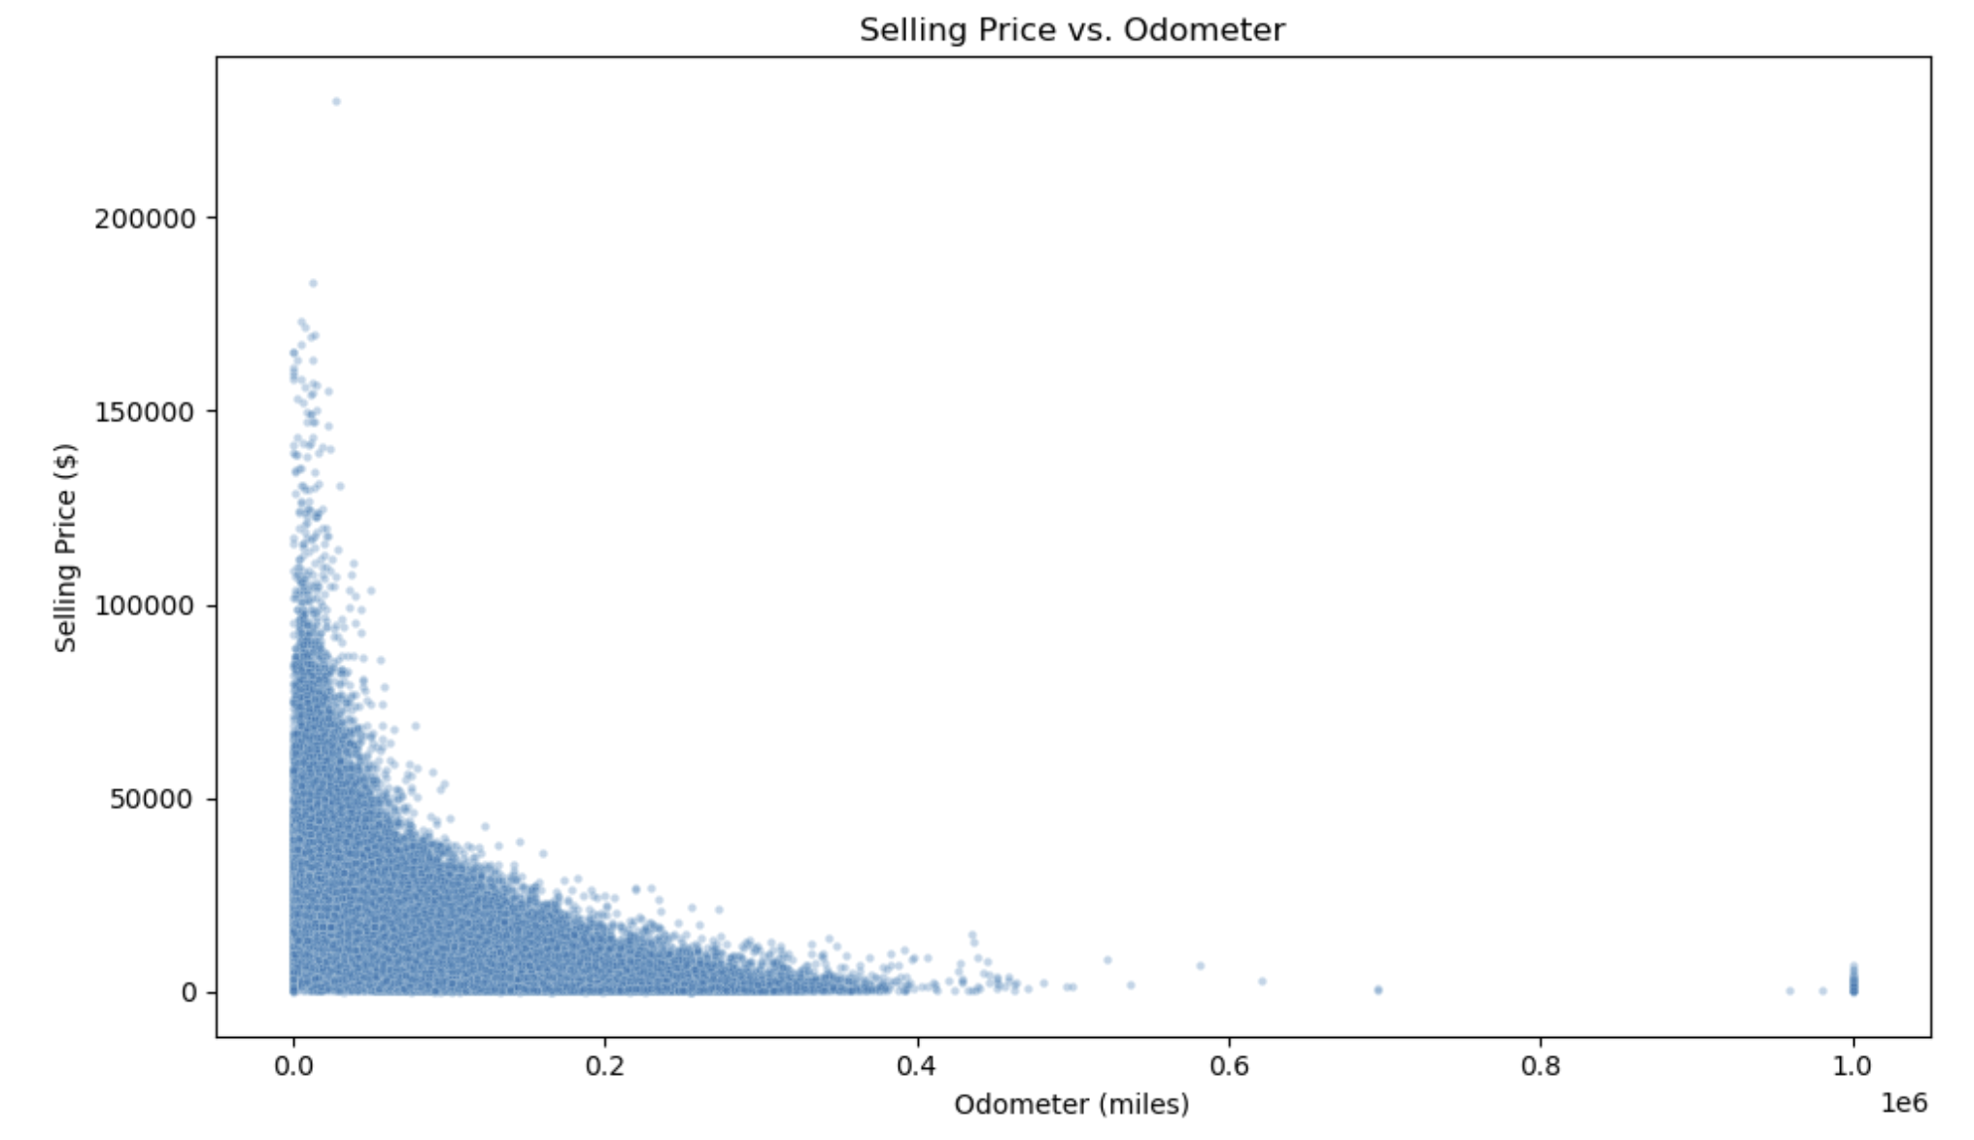
We examined the relationship between the raw selling price and mileage from the scatterplot given below. We noticed that prices decrease sharply at low mileages and flatten out at higher mileages. This is a clear non-linear relationship. To stabilize the variances and obtain a more linear relationship with mileage, we used the log of selling price.
This model allows fair brand comparisons because brands vary widely in their starting price points, so comparing raw price depreciation would be misleading. For example, a luxury vehicle like BMW may start at a much higher price than a Toyota, but what matters for value retention is how quickly the price falls as mileage increases. A log-linear model standardizes this by measuring percentage loss per mile, allowing brands to be compared on an equal footing. We express results as % value lost per 10,000 miles, giving businesses a clear answer to which car brands depreciate the most.
As an example, here is the regression output for Toyota (39,111 observations). The model fits reasonably well, with R² = 0.572. This is a strong value for a model with only one predictor (mileage) as used prices are also influenced by factors such as age, condition, and seller type.
The estimated mileage coefficient is:
$β_{1} = -9.436 ×10^{(-6)} (p <0.001)$
This coefficient implies that Toyota vehicles lose approximately 9% of their value for every 10,000 miles driven.
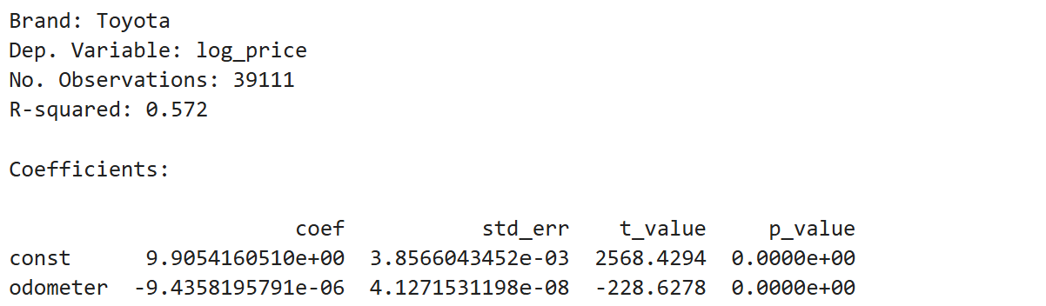
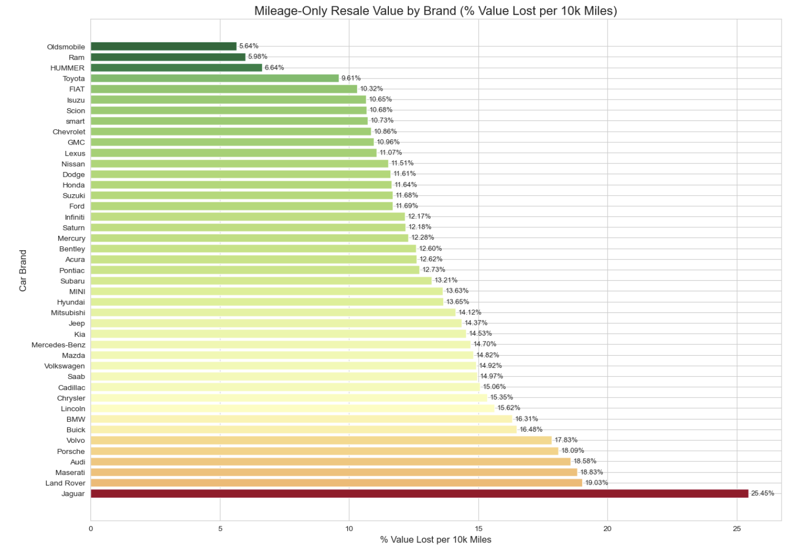
We plotted all car brands to compare, and in the results we see brands like Ram, Hummer, Toyota, and Chevrolet are the ones that hold the most value as mileage increases. On the other end, luxury brands like BMW, Porsche, Maserati, and Jaguar show significantly higher depreciation rates. Jaguar in particular loses about 25% of its value per 10,000 miles driven.
Overall, this model highlights that brands that are known for durability and affordability depreciate slowly as mileage increases, while luxury brands lose value much faster. These findings can help buyers, sellers, and dealerships make more informed decisions around pricing in the used vehicle market.
- What features are important to contribute to deciding the selling price of a used car?
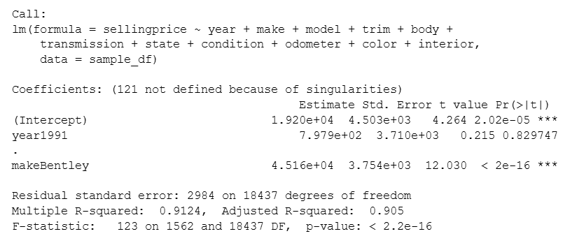
Utilizing the information given in the dataset, we created three different models and compared them to determine which model fits best and which features are most important to determine pricing.
Model A
The summary of Model A indicates that the overall regression is statistically significant, with a model p-value < 0.01. This suggests that the predictor variables collectively contribute to explaining variation in selling price. The model also reports a very high Multiple R² value of 0.9124, meaning it explains roughly 91% of the variation in selling price. The Adjusted R² of 0.905 confirms that the model remains strong even after accounting for the large number of predictors. However, the output also reports “121 coefficients not defined because of singularities.” This occurs when certain dummy variables are perfectly collinear with others, meaning the model matrix does not have full rank.
The ANOVA output shows that most categorical variables are statistically significant predictors of selling price; however, color is one of the least significant variables, and interior also has marginal significance. In contrast, variables like year, make, model, trim, and condition contribute strongly but also introduce multicollinearity due to their high cardinality.
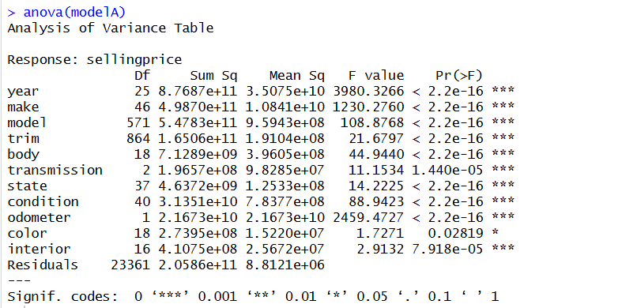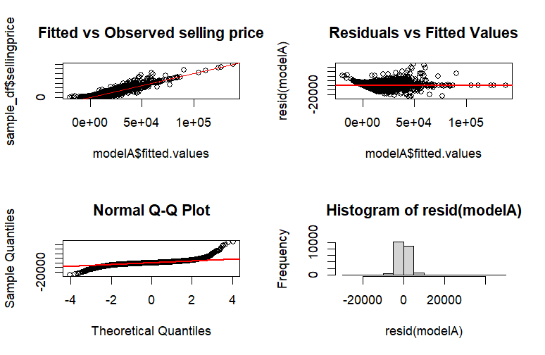
Diagnostic plots further highlight these issues. The fitted vs. observed plot shows that the model captures the overall upward price trend well, but the residuals vs fitted plot reveals a clear pattern rather than random scatter, indicating model misspecification. The Q–Q plot shows approximate normality, but the residual histogram is heavily tailed, suggesting the presence of outliers and skewed error distribution.
Taken together, the evidence indicates that although Model A achieves a high R², the model suffers from multicollinearity, overfitting due to many categorical levels, and the influence of outliers, all of which reduce reliability and interpretability. These limitations highlight the need for data cleaning and model refinement in future models.
Model B
To improve data quality, Model B was built on a dataset cleaned using a two-step outlier removal method:
- IQR filtering removes extreme values of salesDifference, reducing noise and eliminating unrealistic observations.
- Winsorization (1st–99th percentile capping) controlled the influence of remaining high but valid values. This stabilized the distribution while preserving real market variation.
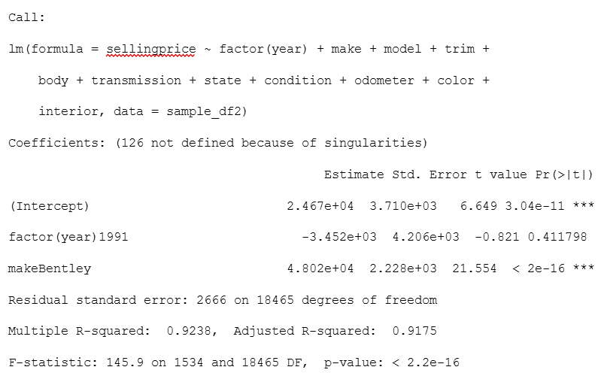
Model B shows strong statistical performance. The regression is highly significant (p < 0.01), and the Multiple R² = 0.9238 with Adjusted R² = 0.9175 indicates that the model explains roughly 92% of the variation in selling price, slightly higher than Model A. This suggests that removing extreme outliers improved model stability. However, R reports “126 coefficients not defined due to singularities,” meaning that even after cleaning, many dummy variables, especially for model and trim, remain perfectly collinear and are automatically dropped.
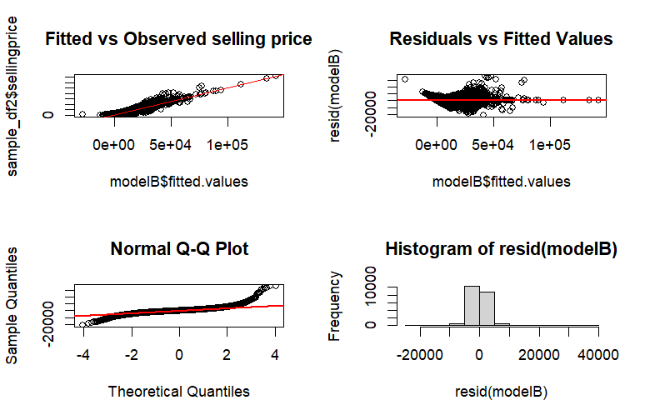
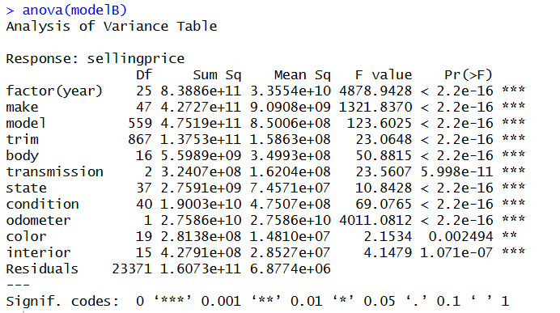
The ANOVA results confirm that while most predictors (year, make, body, condition, odometer) are highly significant, model and trim still have far too many categories, creating redundancy and multicollinearity issues. Color continues to be one of the least significant predictors.
The diagnostic plots further highlight these issues, we found that Fitted vs. Observed values follow the expected trend, but the Residuals vs Fitted plot displays a pattern rather than random scatter, indicating model misspecification. The Q-Q plot shows approximate normality, yet the residual histogram remains heavily tailed, confirming that even after cleaning, the error distribution is still imperfect.
Overall, Model B performs better than Model A due to reduced noise, but it continues to have multicollinearity and high-cardinality categorical variables, limiting its interpretability and reliability.
Model C
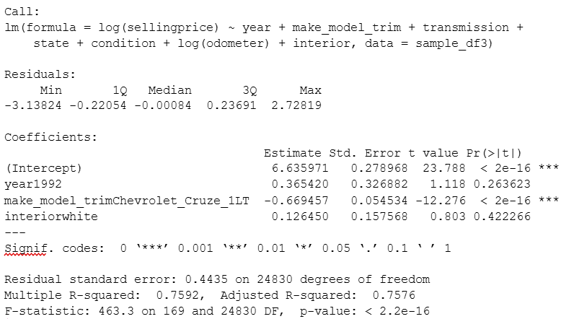
Model C was developed to address the multicollinearity and high-cardinality issues observed in Models A and B. To reduce redundancy, we combined make, model, and trim into a single categorical variable (make_model_trim), significantly lowering the number of dummy variables and preventing singularity errors. Additionally, applying a log transformation to both selling price and odometer helped stabilize variance and correct the heteroscedastic patterns seen earlier. We removed color as it was not as statistically significant compared to other variables.

The performance of Model C is strong and statistically significant, with a Multiple R² of 0.759 and Adjusted R² of 0.758. Although this R² is lower than in Models A and B, it is more realistic and avoids the inflation caused by thousands of dummy variables and multicollinearity in earlier models. The residual standard error of 0.4435 shows that log-transformation successfully reduced spread and improved model stability.

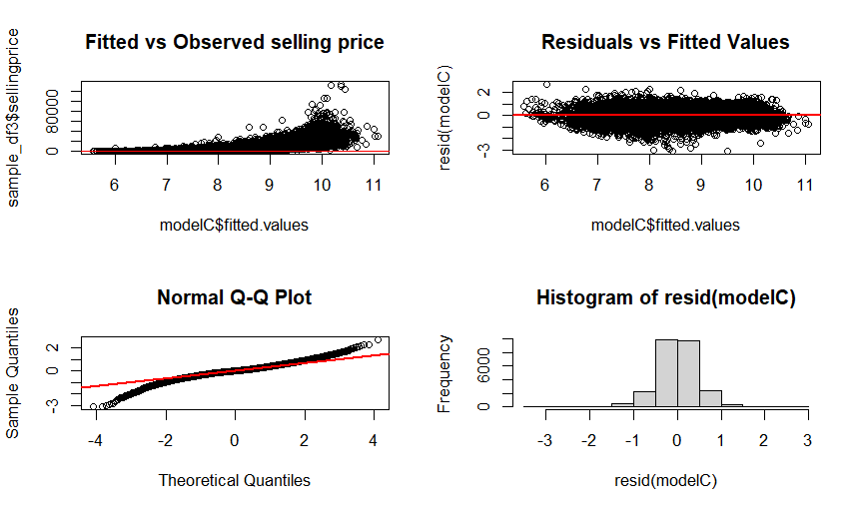
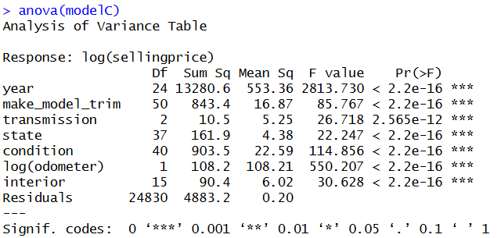
The ANOVA confirms that make_model_trim categories remain significant, indicating that combining them still captures important market differences across vehicle variants. Transmission type, interior color, and state effects also remain statistically relevant. The plots confirm improvement, showing that residuals are more evenly distributed, heteroscedasticity is reduced, and the Q-Q plot better aligns with normality. The plots suggest a much healthier model with fewer regression assumption violations.
In summary, Model C is the most interpretable and statistically reliable model among the three. While Models A and B overfit due to excessive dummy variables and multicollinearity, Model C provides a cleaner representation of real pricing behavior and is suitable for prediction and inference which was confirmed by the VIF score.

ⅠⅠⅠ. Conclusion and Business Value
Our central business problem was to determine which factors strongly influence the resale value of used vehicles in the US. To answer this, we broke the problem into a few guiding questions.
First, we examined how resale values vary across states. The results show clear geographic differences, as some states such as Tennessee, Pennsylvania, Colorado, Nevada, and Michigan consistently exhibit higher average resale prices. Through this analysis, we concluded that location is an important factor in determining the resale value of a used vehicle. For dealerships and sellers, these
state-level price deviation patterns provide a practical framework for pricing and inventory decisions. For buyers, this information can be used to identify specific markets based on locations where vehicles sell for lower prices and to more accurately evaluate whether a particular asking price is fair.
Next, we determined the distribution of the difference in the resale value of the car (selling price vs MMR). Through our analysis, we found that most vehicles sell close to their MMR value. The distribution shifted closer to zero, indicating better alignment with market estimates. When we removed outliers, it reduced variability by ~39%, revealing the true underlying pattern. Lastly, the slight negative mean suggests vehicles typically sell marginally below MMR on average. This is important because the sales difference when comparing the selling price to the MMR value enables accurate pricing strategies and can also help generate margins for profit. The lower standard deviation also means more consistent revenue prediction and can mitigate losses. Understanding the relationship between selling price and MMR can prevent buyers and sellers from overpaying for a vehicle.
Moreover, our analysis shows that value retention varies dramatically across car brands and odometer plays a key role in pricing used vehicles. Brands known for reliability and affordability retain their value far better as the odometer reading increases, typically losing only 5 - 15% per 10,000 miles. In contrast, luxury brands depreciate much faster. Understanding these differences can help buyers and dealers make better pricing and purchasing decisions. For buyers, this means that choosing a high-value retention brand can significantly reduce long-term costs. For sellers and dealers, understanding odometer-based depreciation allows for more accurate pricing and reduces the risk of overpaying during trade-ins. Dealers can also focus on brands that offer stronger resale value.
Lastly, using our model, we can determine that year, make_model_trim, transmission, state, condition, odometer and interior are all important features to decide the selling price of a used car. This is good for dealers to know so they can properly adjust the price for each car to maximize profit. For buyers, this is important to know so they can try to minimize the price they pay for a used car.

Ⅳ. Potential Limitations and Suggestions
- Absence of Time Series Analysis
The dataset mostly contains dates between January 2015 and July 2015, with some data from January 2014. Unfortunately, we don’t have data between January 2014 and January 2015, making it difficult to do a valid time-series analysis. When we tried to analyze a smaller portion of the dataset, the body types that are sold do not change between months. It’s difficult to tell whether this analysis is accurate since we do not have enough long-term data to make that determination.
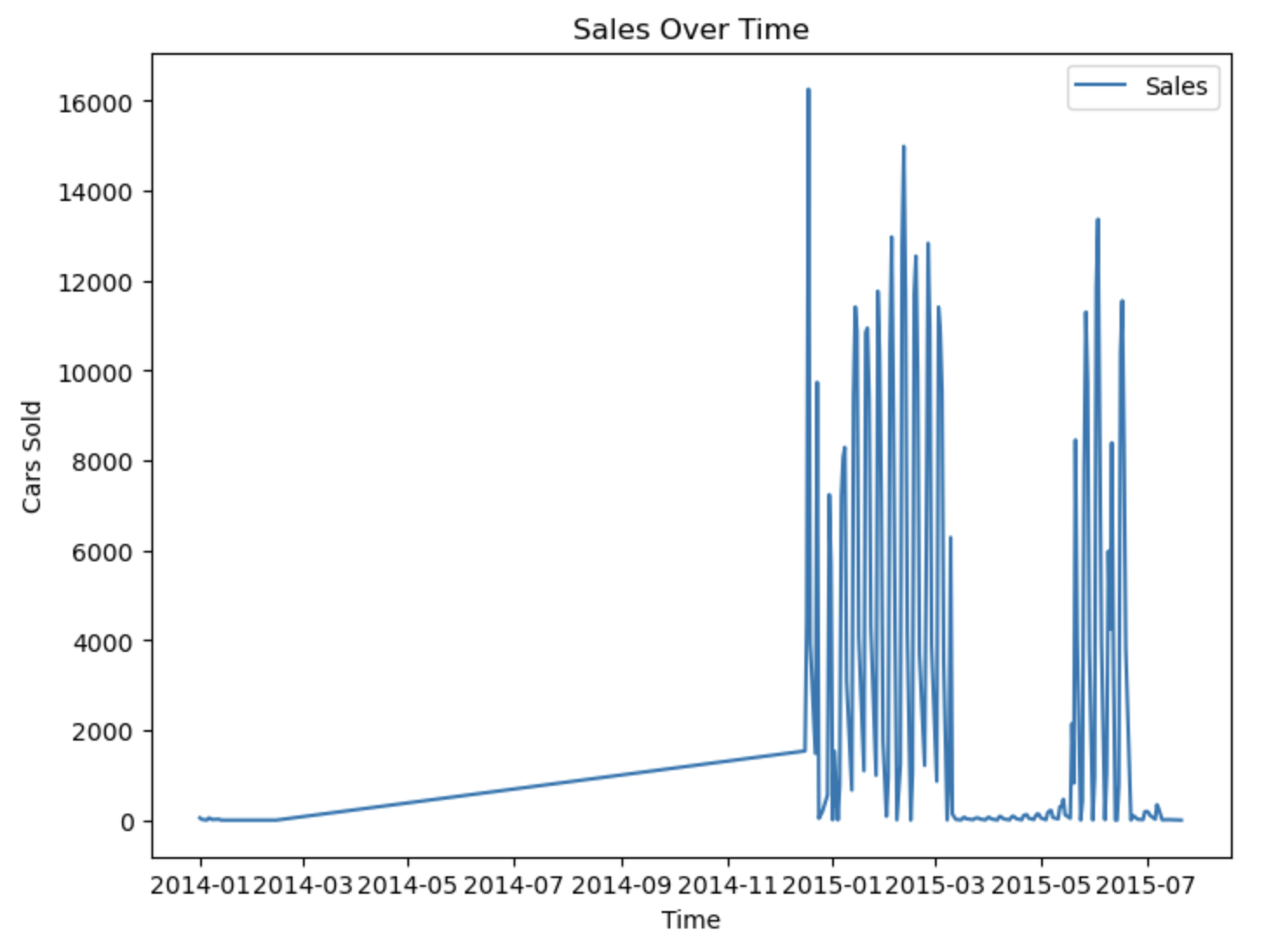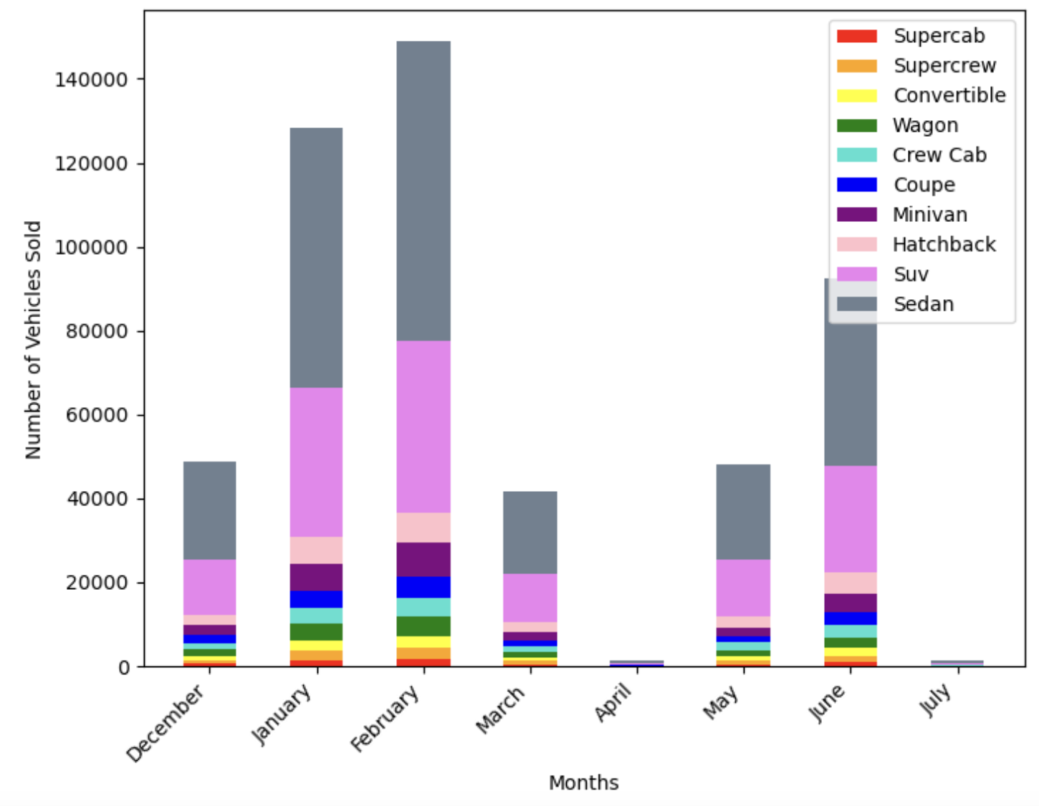
- Suggestions for Further Analysis and Future Decision Making
For future work, we could extend this analysis by incorporating additional vehicle attributes such as MSRP. This would allow us to measure vehicle depreciation more precisely. We could also make use of the repeat-sales dataset (cars with duplicate VINs) we created to study how the same vehicle depreciates across multiple transactions. In addition, predictive models such as random forests could help capture the nonlinear relationships between our attributes. These additions would help produce a more complete and accurate understanding of how used car prices behave.
Citations
Mordor Intelligence. (n.d.). US Used Car Market Size & Share Analysis - Growth and Trends 2025-2030. Mordor Intelligence. Mordor Intelligence Source: https://www.mordorintelligence.com/industry-reports/united-states-used-car-market

Vehicle Sales Data. (n.d.). Kaggle. Retrieved December 3, 2025, from https://www.kaggle.com/datasets/syedanwarafridi/vehicle-sales-data

